What is a Good Software

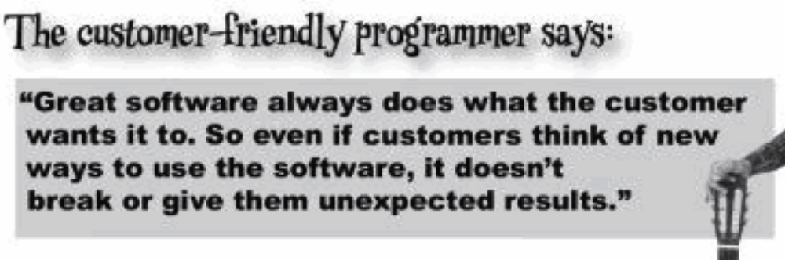

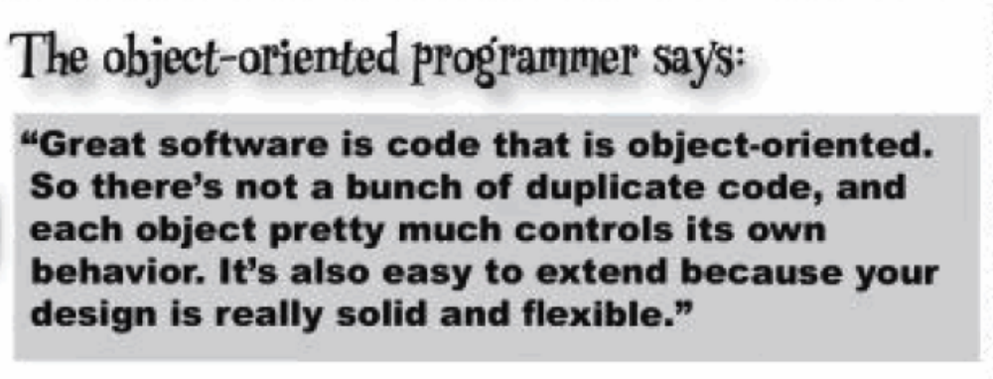

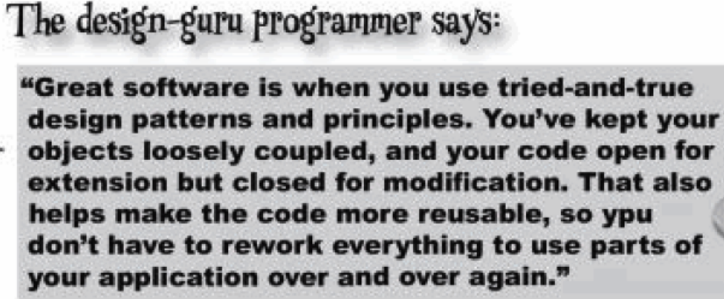

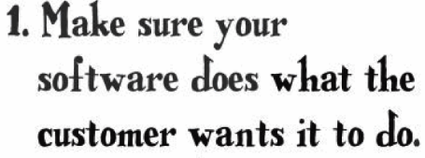
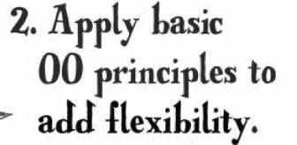

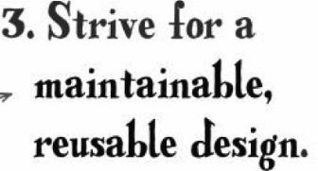

Encapsulate what varies...Ex: Guitar having GuitarSpec.Page30
Delegate the logic. Page 45. One of the common example of delegation in Java is equals() method.

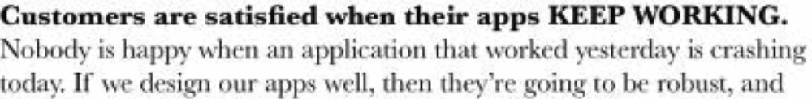

When designing class from requirement, how will you choose class, instance variable, instance method?
1) All the nouns should be class
2) All the verbs should be instance method or behaviour
3) Attribute Association and its multiplicity (List, Set, Map)

